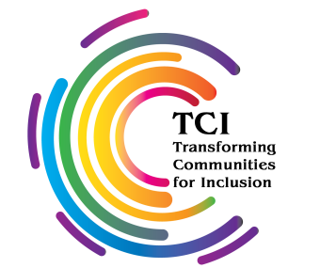
TCI FELLOWSHIP PROGRAM 2026
APPLICATION FORM

SECTION I: PERSONAL DETAILS

Full Name:

Age:

Country/Nationality:

Phone:

Email Address:

Do you identify yourself as a person with a psychosocial disability (Answer Yes or No)?
 | Yes |  | No

Name of the Organisation you are associated with:

Are you or your associated organization is a member of TCI (Answer Yes or No)?
 | Yes |  | No

Please tick the ONE stream you are applying for:
Outreach and Advocacy Fellow – for detailed information, kindly refer to TORs, and the policy note shared with this application form.
Research Fellow - for detailed information, kindly refer to TORs, and the policy note shared with this application form

SECTION II: DETAILS ABOUT THE FELLOWSHIP PROJECT

Briefly state the objectives you may want to achieve with this fellowship and why you need a TCI fellowship?
Briefly describe the why you must be selected for this fellowship stream and how it aligns with the overall objective of the fellowship program as mentioned in the policy note.
Briefly explain your expectations from this Fellowship opportunity with context to your selected stream:

SECTION III: REFERENCES AND DISCLOSURE
Name and contact details of referee 1:
Name:
Organization:
Email Address:
Phone:

Name and contact details of referee 2:
Name:
Organization:
Email Address:
Phone:

Are you currently involved in any other TCI project? If yes, please state the full details of the project.
Please lay-out any other advocacy related work for persons with psychosocial disabilities you are currently involved in?
Please share any other information/details that may or can hinder the completion of your Fellowship program:

